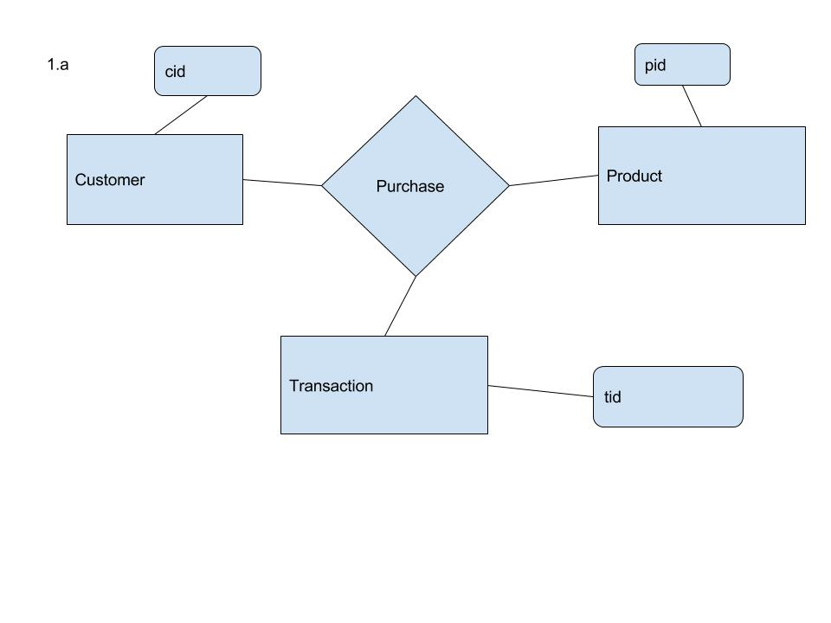

1.a

CREATE TABLE Customer (cid char(20),

PRIMARY KEY(cid))

CREATE TABLE Purchase (cid char(20),

pid char(20),

tid char(20),

PRIMARY KEY(cid+pid+tid),

FOREIGN KEY(cid)REFERENCES Customer,

FOREIGN KEY(pid)REFERENCES Product,

FOREIGN KEY(tid)REFERENCES Transaction,

)

CREATE TABLE Product (pid char(20),

PRIMARY KEY(pid))

CREATE TABLE Transaction (tid char(20),

PRIMARY KEY(tid))

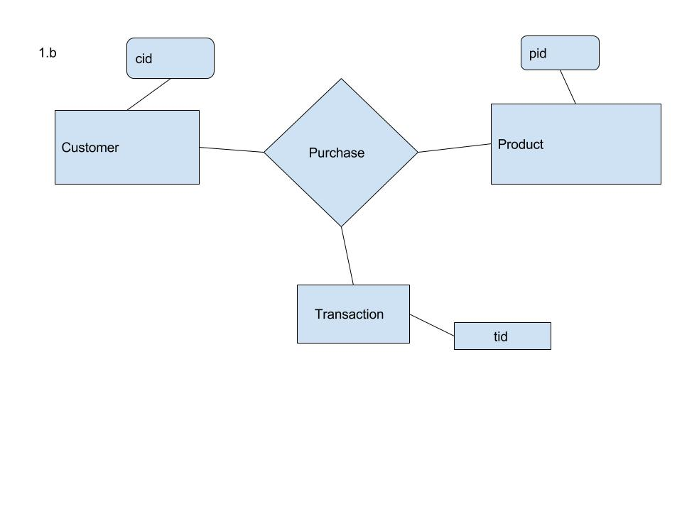

1.b

CREATE TABLE Customer (cid char(20),

PRIMARY KEY(cid))

CREATE TABLE Purchase (cid char(20),

pid char(20),

tid char(20),

PRIMARY KEY(cid+pid),

FOREIGN KEY(cid)REFERENCES Customer,

FOREIGN KEY(pid)REFERENCES Product,

FOREIGN KEY(tid)REFERENCES Transaction,

)

CREATE TABLE Product (pid char(20),

PRIMARY KEY(pid))

CREATE TABLE Transaction (tid char(20),

PRIMARY KEY(tid))

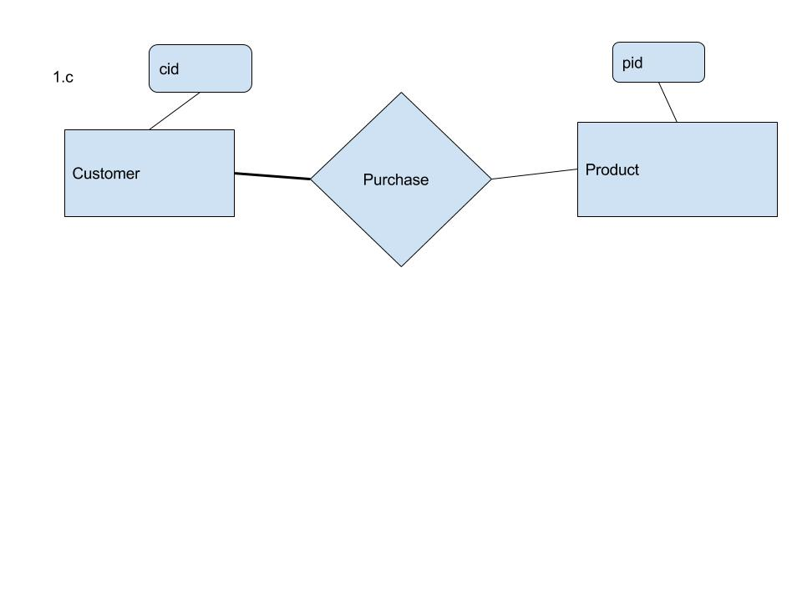

1.c

CREATE TABLE Customer (cid char(20),

PRIMARY KEY(cid))

CREATE TABLE Purchase (cid char(20),

pid char(20)NOT NULL,

tid char(20),

PRIMARY KEY(cid+pid),

FOREIGN KEY(cid)REFERENCES Customer,

FOREIGN KEY(pid)REFERENCES Product

)

CREATE TABLE Product (pid char(20),

PRIMARY KEY(pid))

1.d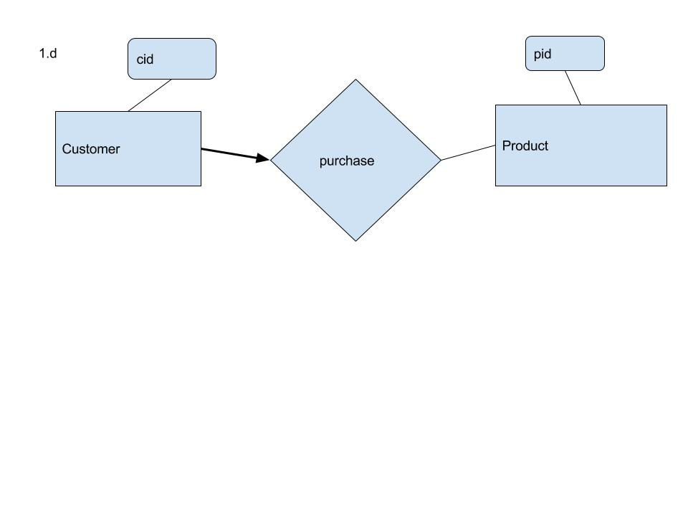

CREATE TABLE Customer (cid char(20),

PRIMARY KEY(cid))

CREATE TABLE Purchase (cid char(20),

pid char(20)NOT NULL,

tid char(20),

PRIMARY KEY(cid),

FOREIGN KEY(cid)REFERENCES Customer,

FOREIGN KEY(pid)REFERENCES Product

)

CREATE TABLE Product (pid char(20),

PRIMARY KEY(pid))